Tub Showers with Style

By Shannon McKinney – DT Glass, Inc

Having a tub shower doesn’t automatically mean you need to abandon your sense of style. Whether it’s your kid’s bath, guest bath, or even a primary bath that doesn’t have room for a separate tub, you can give your tub shower the respect it deserves.

Think about a tub shower and the first image that comes to mind probably includes either a shower curtain, or the old semi-frameless slider with a huge top bar and metal all around. But it doesn’t have to be that way. The choices available for your tub shower are as plentiful as the choices for your full-sized shower.

Give your tub shower the respect it deserves!

**Door and Panel** – The same frameless glass swing door and panel used for full-size showers can also be installed on top of tubs. The only difference is that we won’t drill a hole into your tub to secure the bottom of the panel, instead we’ll use a metal channel and silicone. The glass will be secured at the walls. Of course this design option is only available if there is enough room in front of the tub to allow the door to swing open.

**Double Swing Doors** – If there is ample space in front of your tub, double doors have an amazing look and feel. One of the drawbacks for other glass on a tub is that it limits accessibility. If you use your tub to bathe kids or dogs, blocking a portion of the tub with glass is very inconvenient. Even your own leisurely soak in the tub feels better in a more open space. Double doors are the answer.

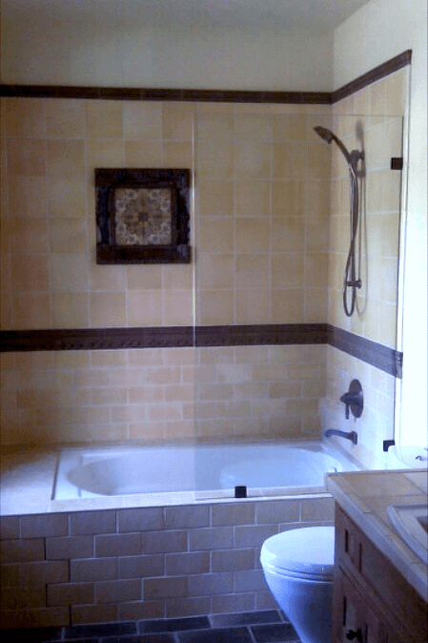

**Shower Shield** – For a little bit of water protection, but not a full enclosure, you could opt for a simple glass panel. Place the glass next to the showerhead, either as a fixed panel, or a hinged door. The hinged door method allows you to open the door to access the shower controls, but the fixed panel will have less water leakage because it’s siliconed in place. Notice I said “a little bit of water protection.” Most shower shield customers experience more water leakage than they expected. Before choosing this option, try setting up a shower curtain to match your planned glass width and see if you’ll be happy with the results.

**Framed or Semi-Frameless Slider** – For years, the go-to tub enclosure has been framed or semi-frameless bypassing shower doors. These enclosures have metal across the top, along the sides, and a sill at the bottom. Even though the look hasn’t changed much over the years, the top mounted rollers have been improved to be smooth, strong, and long-lasting. The bottom sill used to include support for the glass and have channels that collected shower residue and were hard to clean. Today the bottom metal sills are flat, smooth, and easy to clean.

**Barn Door Style Slider** – Custom barn door sliders can be made with no metal at the sides or bottom. It’s the frameless version of sliding glass doors. Layouts include either two bypassing doors, or one operable door and one fixed panel. Pre-fabricated barn door sliders have the exposed roller look at the top, but still include metal sides and a bottom sill to compensate for out of square shower openings and reduce water leakage. See our previous blog for [more information about barn door sliders](https://www.dtglassinc.com/barn-door-slider-blog).

With so many choices, how do you decide? Here are some questions that can help narrow down the options:

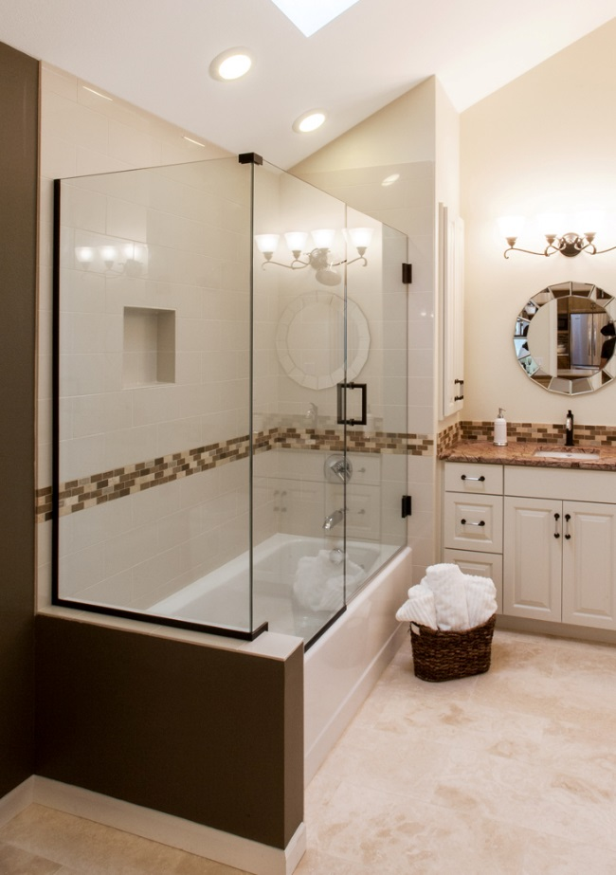*Is there room for a door to swing open?* If not, stick with sliders.

*Is water leakage a major concern?* If so, use a framed or semi-frameless slider.

*Are your shower walls fiberglass?* If so, frameless doors or panels are a bad idea because we don’t want to drill and put weight on your fiberglass walls. Barn door sliders can be installed above the fiberglass walls if you have adequate framing in the walls for support.

*Is style the highest priority?* If so, custom barn door sliders are ideal.

*Is the shower a quick in/out activity?* If so, maybe a simple shower shield will do the trick.

*Do you need full access to the entire tub?* If so, double doors would be great if you have the room. Otherwise, you might need to install a shower curtain (gasp!).

If you were feeling uninspired about your tub shower, I hope this blog has left you with plenty of encouragement. HGTV and Pinterest have no shortage of opulent bathrooms with huge showers and free-standing tubs. However, if you look at the surfaces and details, you can usually find ways to shrink the design to a smaller space or modify it to a new application. Go ahead, fall in love with a look. We’ll help you to apply it to your space.

For more information about shower glass, download our Essential Guide to Frameless Glass Showers. In addition to this 40-page guide, you’ll receive our blogs and other announcements as soon as they’re available, or you can choose a monthly summary.

[Sign me up!](https://www.dtglassinc.com/blog-signup)