Shower & Tub Rooms  
*Japanese Inspired Bathing*

By Shannon McKinney – DT Glass, Inc

Locating the tub and shower together and then enclosing the space is a design trend that has been gaining in popularity.

Though the concept has come into view more often recently, we can’t call it new. It’s ages old. At DT Glass, we’ve had the honor of enclosing wet areas with one of our Japanese designers for years. In Japan, bathing is a ritual that begins with a cleansing shower before moving to the tub to soak. Time spent in the tub is for relaxation, not for washing. Romans had a similar experience. Baths were communal with many people soaking side by side, more like our current hot tubs than our current bathtubs.

Even if you’re keeping your tub all to yourself, you might consider how hygienic it is to hop straight into the bath. Without washing first, the dirt, oil, dead skin cells, and grime of the day are soaking in the water that surrounds you. Despite this, plenty of Americans still choose to clean their bodies while sitting in the tub. After all, baths are how our parents taught us to get clean while growing up.

Now imagine you’re finished washing and soaking in the tub. When you rise from the tub, do you feel as though a rinse is in order? Most bathroom configurations would require a cold, wet, slippery trek across the room, dripping water on the floor along the way. Locating the tub and shower together means staying in an enclosed space on a floor that’s designed to be dripped on.

**Designing Your Tub & Shower Room**

Shower and tub placement for an enclosed wet space is often very different than for a standard bathroom design. Transforming an existing space is likely to require extensive demo and rerouting of plumbing. When considering placement, think about the tub and shower as one unit, perhaps placed together at the end of a long bathroom or in one corner of a larger space. Waterproofing should be extensive. The entire tub & shower room should be treated as though it's the inside of a shower. Partial waterproofing, as you might usually do around a tub, is not enough to guard against the adjacent shower spray.

Japanese bathing is a ritual that begins with a cleansing shower before moving to the tub to soak.

**Drawbacks to Combining Your Tub and Shower Space**

For a remodeling project, the biggest drawback to this configuration will be the extent of the work required to achieve it. A full demo and re-pipe can become expensive. Incorporating these plans in a new construction project can be easier.

Other potential drawbacks relate to how happy you might be with the use of the space. First, the large open space may seem luxurious, but that big open airiness could get cold and drafty. Second, when you’re showering alongside your tub, the inside, outside, and floor around it are all going to get wet. Cleaning the tub will probably need to be done more thoroughly and more often.

**Does it Fit Your Lifestyle?**

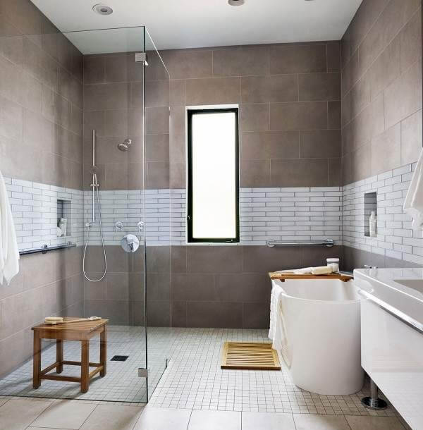I can’t help but wonder if today’s shower and tub wet room is going to follow the path of the giant whirlpool tubs of the 80’s. Everyone loved the idea and had to have one. Yet over the course of a year most homeowners reported using their tub only once or twice. If you place a tub in your shower and don’t use it, not only will it be wasting space, but you’ll be wasting time cleaning it. There’s also the opportunity cost of using your space and budget toward a luxury you’re not using, when instead you could have chosen features and designs that you would appreciate long-term.

**Selecting your Glass Layout**

Enclosing both the shower and the tub is often as straight forward as enclosing a shower alone. When issue

s do arise, it’s usually related to a large opening with oversize panels that need additional support or a door that can’t be positioned to swing off the wall. Please see previous blogs about [*Oversized Glass Panel Support*](https://www.dtglassinc.com/oversized-panel-blog) and [*Frameless Shower Door Placement*](https://www.dtglassinc.com/door-placement-blog).

**Tub & Shower Combo vs Tub & Shower Room**

Our last blog [*Tub Showers with Style*](https://www.dtglassinc.com/tub-shower-combo-blog) was written like a consolation prize for the homeowner who wasn’t fortunate enough to have a separate tub and shower. However, doesn’t it make sense to think of a tub and shower combo as the miniaturized version of a tub and shower room? Perhaps we should consider tub and shower combo owners as completely on trend!

If you think that a tub and shower room might be right for you, we’re here to help. From surface materials, to plumbing and fixtures, there are so many options to choose from. We may not be able to guide you through all the choices, but at least we can help you make sense of the glass choices. And remember we’re available at the pre-planning stage too.

For more information about shower glass, download our Essential Guide to Frameless Glass Showers. In addition to this 40-page guide, you’ll receive our blogs and other announcements as soon as they’re available, or you can choose a monthly summary.

[Sign me up!](https://www.dtglassinc.com/blog-signup)