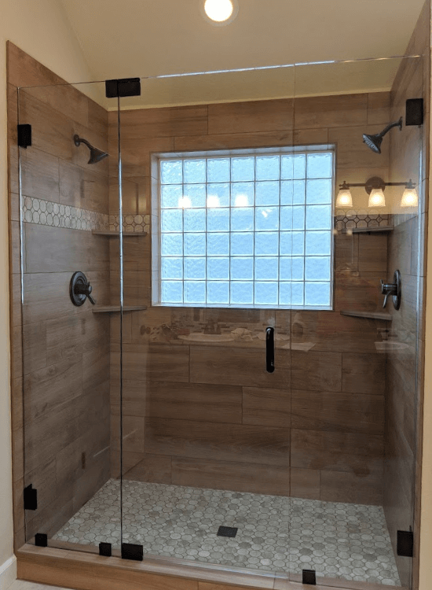When to Use ½” Glass  
By Shannon McKinney – DT Glass, Inc

When it’s time to select the glass for your frameless glass shower or interior partition, you might wonder if ½” glass would be a better choice than the more common 3/8” glass. Usually, the underlying question is if the thicker glass will provide greater strength and stability, or produce a higher quality result.

The first assurance we’ll provide is that we won’t install any shower that isn’t structurally sound. If your shower design requires ½” glass for stability, then that’s what we’ll provide. If cost savings are needed, then we can usually redesign the layout or reduce overall sizes to provide an alternative in 3/8” glass that is still safe and secure.

If on the other hand, it’s not necessary to use ½” glass for your project, but you simply prefer the look of a thicker and more substantial piece of glass, we are happy to make that change. Please note that in some cases, this might also require a change to larger hardware.

*When is it important to use ½” thick glass?*

We’ll use the rest of the blog to explain those situations.

**Panel Supporting a Door –** When a swing door can’t hinge directly from a wall, one alternative is to use heavy-duty clamps and a thicker ½” panel as support. There are limitations to how big the support panel can be, as well as size and weight restrictions on the door, but in the right situations it creates a nice, clean, frameless look.

**Panels Over 108” Tall –** When extra tall ceilings call for extra tall panels, or when panels attach to the ceiling, it’s time to switch to thicker glass at 108”. Even if the glass is secured around all four edges, there is flex in the center of the panel at these heights.

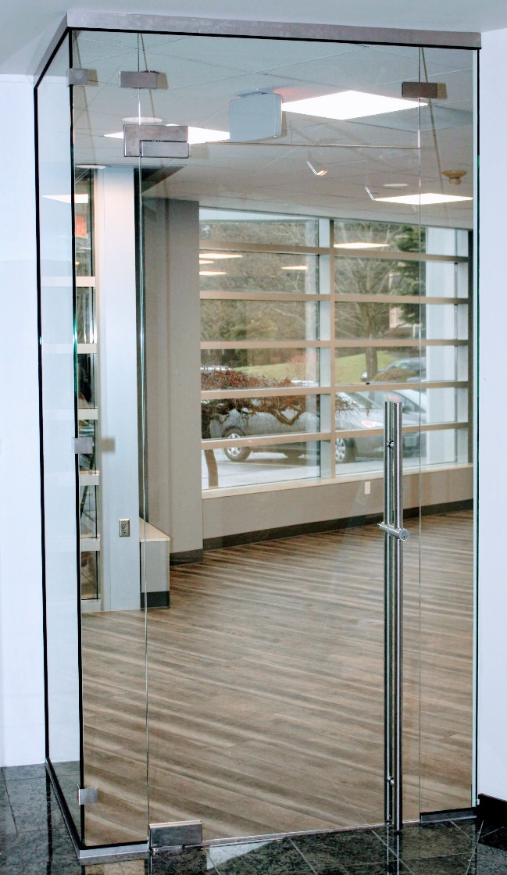**Commercial Applications –** Commercial settings experience heavier usage than residential settings. Your home shower, interior slider, and wine room will be used far less frequently than the glass doors and partitions in an office building. Office glass experiences daily abuse from the general public who will never love it the way you love your glass at home.

**Thermal or Sound Insulation –** ½” glass will be better than 3/8” glass at keeping your wine room cold, or your sauna hot, or your office quiet. Notice that I’m only comparing two thicknesses of monolithic glass, though. Monolithic glass is a single thickness of glass, which is very capable of transferring temperature and sound. 3/8” glass will be better than ¼” glass, and ½” glass will be better than 3/8” glass, but double-paned insulated units will be better than any monolithic option. Unfortunately, window glass isn’t an option for a lot of interior applications.

**Mixing ½” Panels with 3/8” Doors –** The need for ½” glass may apply to only one piece of glass, and not the whole shower. This could cause concern that it will look strange to use multiple thicknesses of glass. In our experience, the difference is mostly noticeable to the person who is already aware of it. It becomes an aesthetic question about whether or not it will bother you long-term to know that the glass is different thicknesses.

If you simply prefer the look of thicker glass, we’re happy to accommodate that choice!

The best way to find out if ½” glass is the right choice, is to talk to us about your specific project. We can help you weigh the pros and cons, or help you redesign a layout for better results. Our showroom features full-size 3/8” glass displays, ½” glass displays, and a display with a combination of both thicknesses. There’s no better way to decide what’s right for you than to see it in person.

For more information about shower glass, download our Essential Guide to Frameless Glass Showers. In addition to this 40-page guide, you’ll receive our blogs and other announcements as soon as they’re available, or you can choose a monthly summary.

[Sign me up!](https://www.dtglassinc.com/blog-signup)