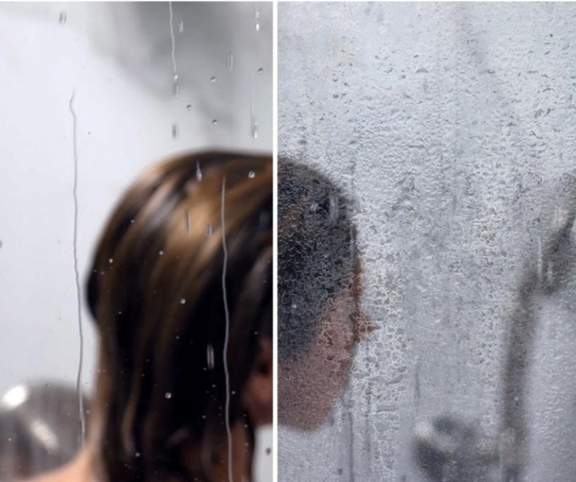Glass Coating

for Easier Cleaning

By Shannon McKinney – DT Glass, Inc

Clear glass is beautiful. It shows off the shower tile, it lets the light shine through, and it creates an open look and feel. But glass stained with water spots, soap scum, and mineral deposits can be an eyesore.

Coated shower glass versus un-coated.  
All pictures by Diamon-Fusion.

We hear it all the time “I’d love to have clear glass, but I worry about being able to keep it clean.” Glass coating was designed to give you those wonderful benefits of clear glass without the drawback of dirty, hard to clean glass.

**How does glass coating work?**

**Let’s run through the problem, the solution, and the choices available.**



**The Problem –** Most people think of glass as having a smooth surface, but at a microscopic level it’s made up of lots of ridges and valleys and is quite porous. While the water is hitting our body during a shower, it’s also hitting the glass and carrying foreign materials with it. Your water may contain calcium, lime, and rust, your shower products hit the glass with shampoo residue and soap scum, and your body itself is releasing dead skin cells, along with the dirt and debris of the day. The water lands on the glass, attaching itself to the ridges and seeping into the valleys. The water itself evaporates leaving the foreign materials not just *on* the surface of the glass, but *within* the surface of the glass.

At a microscopic level, the surface of glass has ridges and valleys.

**The Solution –** Glass coating serves two important purposes. First, it causes the water to bead up and roll off the glass. When water spends less time on the glass, it has less chance of leaving behind its nasty companions. Second, it fills in the ridges and valleys so that the debris never actually touches the glass and can never become imbedded in its surface. Not all of the water will bead up and roll away, so even a coated surface will experience water spotting. The good news is that the spotting is on the coating and not the glass itself. When you clean a coated shower, you’re not actually cleaning the glass, you’re cleaning the coating, and the coating has been designed to be easy to clean.

**The Choices –** There are multiple glass coating products available to commercial glass fabricators, and others available to after-market consumers. At DT Glass, we selected Diamon-Fusion glass coating for its dependable results, trouble-free application, and the manufacturer’s excellent customer service. Other fabricators use other products, which means that often the choice of coatings will be dictated by the glass fabricator, not the end user. However, as much as we love Diamon-Fusion, it is better to have *any* coating than to have *no* coating. In fact, if your glass has been installed without any factory-applied glass coating, you can still benefit from an after-market product like Rain-X, or even a generic car wax, you’ll just need to reapply it more often. Diamon-Fusion has a DIY kit too. Remember, the goal is to do anything you can to create a barrier between the glass and the materials that have the potential to damage it.

**Cleaning and Maintenance –** Even with a glass coating, it’s important to use a squeegee after every shower; it wipes away the remaining droplets of water. The glass should also be cleaned about every other week with a mild dishwashing soap and a soft cloth, or a nylon body pouf. If your cleaning regimen isn’t quite as consistent as it should be, you will still experience water spotting. The good news is that the minerals, residue, and debris are on the coating, not on the glass. If the normal cleaning methods aren’t working, the manufacturer of our Diamon-Fusion product have a special cleaning kit with a heavy-duty cleaner to attack the problem, and a revitalizing solution to bring the coating back to as good as new.

ANY coating is better than NO coating.

We recommend glass coating on every shower we sell. That probably sounds self-serving, and it is, but not for the reason you may think. Glass coating provides additional revenue for us, which is great. But there are two even better reasons:

1. You’re more likely to keep your glass clean when it’s easy to do. When you show off your shower and tell your friends you got it from DT Glass, we want it to look beautiful, so they’ll want one too.
2. Years from now, if cleaning and maintenance haven’t been consistent and the water spotting has gotten out of control, we can get you back on track if your shower glass was coated. We hate to disappoint our customers without coating when we tell them there’s nothing we can do.

Ready to order your shower… with a side of coating? Give us a call, email, or come to the showroom and we’ll help you create a shower that looks beautiful AND is easy to keep clean.

For more information about shower glass, download our Essential Guide to Frameless Glass Showers. In addition to this 40-page guide, you’ll receive our blogs and other announcements as soon as they’re available, or you can choose a monthly summary.

[Sign me up!](https://www.dtglassinc.com/blog-signup)