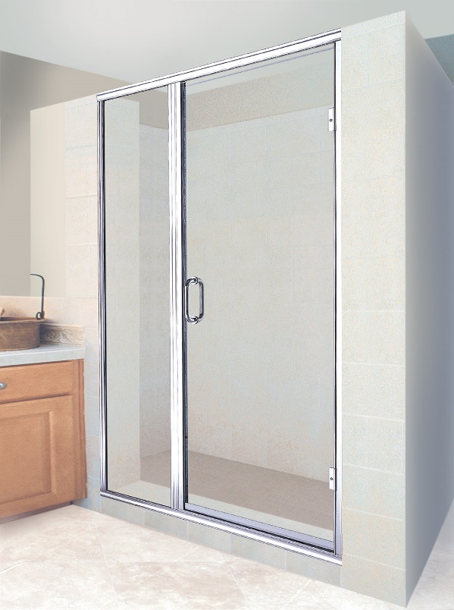
4 Reasons to Choose a Semi-Frameless Shower (instead of frameless)
By Shannon McKinney – DT Glass, Inc

HGTV, magazines, Pinterest and Houzz will tell you that a Frameless Glass Shower is the best choice for your home. Admittedly, at DT Glass we prefer frameless showers, and that’s what we produce in our own fabrication plant. But it doesn’t matter what other people think, it’s about you and what’s right for your space.

The #1 selling feature for frameless glass showers is aesthetics. The minimal hardware makes it smooth, sleek, and modern. If this is the look you want in your home, or if you want to attract a high-end buyer at resale, then a frameless glass shower may be the right choice. However, even in higher end homes there might be a choice to splurge in the primary bathroom, while saving money on the semi-frameless shower in the kid’s, or guest bath.
Agalite Accent

The #1 selling feature for semi-frameless showers is practicality.
- Water Resistance – It may not be a “showstopper”, but it is a much better “water stopper”. All that metal serves a purpose; it keeps the water in the shower. This is a benefit that should not be overlooked when planning for a small shower, an active kid’s shower, or where water leakage is a concern near hardwood floors or water-sensitive moldings.
- Budget – Practicality also extends to cost. Semi-frameless showers are mass-produced, which lowers the per unit cost. However, mass production relies on pre-determined sizes, and metal fillers are used to make up the difference between the size of the opening and the size of the glass. The range of sizes and customizations available will vary from manufacturer to manufacturer.
- Fiberglass Surrounds – Semi-frameless showers may be the only option when your shower has fiberglass walls. A frameless glass shower should only be installed on tile or stone walls. The pressure of heavy glass hinges on fiberglass walls could cause cracking and breaking, leading to water intrusion.
- Upgrades – Some manufacturers will provide built-in upgrades or special perks to differentiate their products from the competition. For example, Agalite offers rain glass or obscure (P516) glass as an upgrade at no additional cost. Fleurco products all come with glass coating. When manufacturers mass-produce their product, it can be fairly inexpensive to add a benefit to the consumer. If it’s a benefit that’s important to you, it can make a big difference in a side-by-side price comparison and the final purchase decision.

The #1 selling feature for frameless glass showers is aesthetics.
The #1 selling feature for semi-frameless showers is practicality.

What is a Semi-Frameless Glass Shower?
Semi-frameless glass showers get their name from the combination of fully framed panels and frameless doors. Doors will have a metal drip rail, and may have a full metal hinge, but do not have metal at the strike edge or top, which allows them to be called “frameless”. The panels are usually made from 3/16” or 1/4” glass, which is not thick enough to support itself, so it must be wrapped in metal.

The metal used in semi-frameless shower installations fills the spaces between glass panels to stop water, provides a strip for the door to close against, and includes a drip tray to direct water back into the shower. The metal also creates adjustability to make up the difference between the prefabricated standard size of the unit and the actual size of the opening.

In comparison, a fully-framed glass shower is made of even thinner glass, which requires the door to also be wrapped in metal. A frameless shower, on the other hand, is made from 3/8” or 1/2” glass which is thick enough to support itself without being wrapped in metal. Please see our previous blog post “What Makes a Frameless Glass Shower Frameless” for more details about frameless glass.

Finally, a hybrid option exists between semi-frameless glass showers and frameless glass showers. This prefabricated shower option combines a 1/4” thick glass door with a 3/8” thick glass panel. At these thicknesses, neither the door nor the panel need to be wrapped in metal. The sides and bottom sill are still full lengths of metal, but this configuration removes the need for the dreaded metal header across the top of the shower. Size and layout restrictions apply, but it’s worth finding out if this type of shower is possible for your space. We love using this product to help homeowners with fiberglass stalls get as close as they can to a frameless glass shower.

How do you find the right semi-frameless shower?
Not only are there a wide variety of semi-frameless shower manufacturers, but every manufacturer offers a variety of product lines. The most important thing to remember when evaluating options is that the quality of the materials will be the number one determinant of price. Here are things to compare from product to product:

- Thickness of the glass. Thicker glass will not allow for through-glass installation of handles, hinges, or other hardware. Thinner glass will have hardware that is pressure-fitted and glued.
- Quality of the hardware. Some thin metal extrusions can bend in your hand and will not hold up over time. On-line photos will not help you identify low-quality hardware, it’s best to see and feel the product in person. If that’s not possible, you might be able to compare product warranties to get an idea of how long you can expect it to last.
- Available colors, patterns, and handle options. If you’re looking for clear glass and chrome hardware, you’ll have lots of products to choose from. But if you want Champagne Bronze hardware with Frosted Glue Chip glass and a specialty handle that matches your cabinet hardware, you may be in for a search. The price to customize a prefabricated shower can also be prohibitive. Remember, these manufacturers are purposefully catering to the masses.

The most important thing to remember when evaluating options is that the quality of the materials will be the number one determinant of price.

- Know what type of buyer you are. This may sound strange, but many manufacturers will tell you the quality of their product with the name, because they want to attract the right buyer. When you see a “Builder’s Basic” product line, you know it’s been created for the high-volume builders who need to watch their costs so that they can offer their homes at a competitive price. Most builder warranties only last a year, so longevity is not as important to them as it is to a homeowner who’s remodeling a home they want to spend the rest of their lives in.
- Available sizes. You’ll want the available glass sizes to match as close as possible to your actual shower opening. Some manufacturers will use up to 6” of metal to fill the gaps between the glass size they offer and the size you need. Providing lots of options will increase the manufacturers cost to produce the product but reducing the size of the metal fillers might be worth the additional cost.

Is a semi-frameless glass shower the right choice for you and your space? At DT Glass, we help designers, contractors, and homeowners weigh the pros and cons for every situation. We don’t want to sell you our favorite shower, we want to find the right shower for you. We’re always available to discuss your specific project: by phone, through email, in our showroom, or an on-site consultation.

At DT Glass, we are committed to breaking through the barriers between homeowners and the showers of their dreams. A cornerstone of this mission is educating and informing our customers. Please visit our website for additional blogs and inspiration.

